Table S1. Nanoplot Summary Statistics, _R=Rincón _M=Mayagüez locality for Anadenobolus monilicornus Oxford Nanopore libraries. Kraken2_nr is kraken run in protein mode to the nr database | Mean read length: | 1,585 | 1,821 | 3,965 | 3,302 | 1,611 | 1,157 | 1,833 | 2,230 | 2,048 | 2,103
 | Median read length: | 1,004 | 1,444 | 3,511 | 2,924 | 582 | 532 | 1,170 | 1,832 | 1,371 | 1,750
 | Number of reads: | 68,661 | 81,096 | 4,564 | 1,990 | 2,682 | 5,805 | 2,271 | 3,654 | 37,630 | 54,778
 | Read length N50: | 2,278 | 2,374 | 4,823 | 3,821 | 4,417 | 2,380 | 2,833 | 2,890 | 3,047 | 2,667
 | Total bases: | 108,799,383 | 147,699,947 | 18,096,584 | 6,571,549 | 4,321,336 | 6,717,626 | 4,163,698 | 8,149,461 | 77,076,857 | 115,172,741
 | General summary: | Kraken2_nr_R | Kraken2_nr_M | MEGAN-LR_R | MEGAN-LR_M | GraphMap_R | GraphMap_M | Minimap2_R | Minimap2_M | Kraken2_R | Kraken2_M

Table S2. List of Nematoda genomes downloaded from WormBase and added to the custom Kraken2 nucleotide database.
PRJNA62057
PRJNA80881
PRJNA10729
PRJEA64437
PRJNA51225
PRJNA20035
PRJNA10731
PRJNA13758
PRJNA275000
PRJNA12591
PRJNA248909
PRJNA53967
PRJNA194557
PRJNA53597
PRJNA194557
PRJNA53597
PRJEB1797
PRJNA13977
PRJEB506
PRJNA205202
PRJNA60051
PRJNA29083
PRJEA28837
PRJNA72135
PRJEB513
PRJEB6009
PRJNA12644
PRJNA186477
PRJEA62033
PRJEB125
PRJNA12603
PRJNA208416

Table S3. Summary Statistics from iNext of reads assigned to Phylum and Class level to ONT reads for Rincón and Mayagüez samples by five different methods. n=numbers of reads, S.obs=number of species, C.hat= estimator of the sample coverage of the reference sample.
Rincón_Phylum
 | Kraken2_nr | MEGAN-LR | GraphMap | Minimap2 | Kraken2
n | 1276 | 3838 | 2681 | 2254 | 34438
S.obs | 17 | 39 | 10 | 24 | 41
C.hat | 0.9977 | 0.995 | 0.9993 | 0.9973 | 1
Rincón_Class
 | Kraken2_nr | meaganLR_nr | GraphMap | Minimap2 | Kraken2
n | 1266 | 2402 | 1646 | 2132 | 13508
S.obs | 24 | 48 | 18 | 38 | 84
C.hat | 0.9945 | 0.9921 | 0.9976 | 0.993 | 0.9993
Mayagüez_Phylum
 | Kraken2_nr | MEGAN-LR | GraphMap | Minimap2 | Kraken2
n | 2053 | 1818 | 5805 | 3612 | 50213
S.obs | 24 | 45 | 12 | 24 | 50
C.hat | 0.9961 | 0.9918 | 0.9997 | 0.9981 | 0.9999
Mayagüez_Class
 | Kraken2_nr | MEGAN-LR | GraphMap | Minimap2 | Kraken2
n | 2007 | 1506 | 4627 | 3380 | 19077
S.obs | 25 | 64 | 16 | 44 | 86
C.hat | 0.997 | 0.9887 | 0.9998 | 0.9967 | 0.9994

Table S4. Phylum level taxonomic annotation of ONT reads assigned by different ONT read alignment programs.
Mayagüez Phylum | Kraken2_nr | MEGAN-LR | GraphMap | Minimap2 | Kraken2
Acidobacteria | 0 | 30 | 0 | 3 | 10
Aquificae <phylum> | 0 | 0 | 0 | 0 | 10
Caldiserica | 0 | 0 | 0 | 0 | 1
Calditrichaeota | 0 | 0 | 0 | 0 | 2
Chrysiogenetes <phylum> | 0 | 0 | 0 | 0 | 1
Deferribacteres <phylum> | 0 | 3 | 0 | 0 | 7
Dictyoglomi | 125 | 0 | 0 | 0 | 6
Elusimicrobia | 0 | 7 | 0 | 0 | 5
environmental samples <Bacteria> | 0 | 5 | 0 | 0 | 0
Bacteroidetes | 21 | 514 | 0 | 41 | 686
Chlorobi | 0 | 1 | 0 | 0 | 6
Ignavibacteriae | 0 | 1 | 0 | 0 | 5
Candidatus Cloacimonetes | 0 | 0 | 0 | 0 | 2
Gemmatimonadetes | 0 | 0 | 0 | 0 | 1
Fusobacteria | 0 | 1 | 0 | 1 | 50
Nitrospirae | 3 | 2 | 0 | 0 | 5
Proteobacteria | 1663 | 426 | 46 | 390 | 2287
Chlamydiae | 2 | 12 | 0 | 0 | 11
Lentisphaerae | 0 | 16 | 0 | 1 | 2
Planctomycetes | 27 | 49 | 0 | 6 | 16
Verrucomicrobia | 0 | 104 | 0 | 58 | 52
Spirochaetes | 32 | 16 | 11 | 2 | 82
Synergistetes | 1 | 21 | 0 | 2 | 10
Actinobacteria <phylum> | 102 | 21 | 3 | 41 | 545
Chloroflexi | 8 | 0 | 0 | 0 | 14
Candidatus Margulisbacteria | 0 | 1 | 0 | 0 | 0
Candidatus Melainabacteria | 0 | 2 | 0 | 0 | 0
Cyanobacteria | 1 | 2 | 1 | 0 | 223
Deinococcus-Thermus | 9 | 0 | 0 | 0 | 12
Firmicutes | 7 | 381 | 12 | 2327 | 9555
Tenericutes | 2 | 6 | 1 | 25 | 157
Thermodesulfobacteria <phylum> | 1 | 0 | 0 | 0 | 3
Thermotogae <phylum> | 0 | 1 | 0 | 0 | 21
Candidatus Saccharibacteria | 0 | 1 | 0 | 0 | 1
Candidatus Gracilibacteria | 0 | 0 | 0 | 0 | 6
Candidatus Vecturithrix | 0 | 1 | 0 | 0 | 0
unclassified Bacteria (miscellaneous) | 33 | 3 | 0 | 0 | 2
Vampirococcus | 0 | 0 | 0 | 0 | 1
Euryarchaeota | 1 | 10 | 0 | 1 | 105
Crenarchaeota | 0 | 0 | 0 | 0 | 23
Thaumarchaeota | 0 | 0 | 0 | 0 | 7
Apicomplexa | 0 | 0 | 39 | 8 | 146
Ciliophora | 0 | 6 | 0 | 0 | 22
Amoebozoa | 0 | 0 | 0 | 0 | 19
Cryptophyta | 0 | 0 | 0 | 1 | 1
Kinetoplastida | 0 | 0 | 2 | 0 | 18
Ascomycota | 3 | 1 | 2 | 22 | 250
Basidiomycota | 1 | 0 | 0 | 1 | 5
Microsporidia | 0 | 1 | 0 | 0 | 0
Mucoromycota | 0 | 2 | 0 | 0 | 0
Chordata | 2 | 13 | 0 | 0 | 0
Echinodermata | 0 | 2 | 0 | 0 | 0
Hemichordata | 0 | 1 | 0 | 0 | 0
Platyhelminthes | 0 | 3 | 0 | 0 | 0
Nematoda | 1 | 7 | 315 | 86 | 1354
Arthropoda | 1 | 115 | 3932 | 318 | 930
Priapulida | 0 | 1 | 0 | 0 | 0
Annelida | 0 | 1 | 0 | 0 | 0
Brachiopoda | 0 | 1 | 0 | 0 | 0
Mollusca | 0 | 3 | 0 | 0 | 0
Cnidaria | 0 | 17 | 0 | 0 | 0
Parabasalia | 0 | 1 | 0 | 0 | 0
Chlorarachniophyceae | 0 | 0 | 0 | 1 | 0
Rhodophyta | 0 | 0 | 0 | 2 | 4
Bacillariophyta | 0 | 0 | 0 | 1 | 13
Chlorophyta | 0 | 0 | 0 | 9 | 21
Streptophyta | 6 | 5 | 1441 | 265 | 33498
Viruses | 1 | 0 | 0 | 0 | 0
unclassified sequences | 0 | 1 | 0 | 0 | 0
TOTAL | 2053 | 1818 | 5805 | 3612 | 50213

Table S5. Phylum level taxonomic annotation of ONT reads assigned by different ONT read alignment programs.
Rincón Phylum | Kraken2_nr | MEGAN-LR | GraphMap | Minimap2 | Kraken2
Acidobacteria | 0 | 4 | 0 | 2 | 4
Aquificae <phylum> | 0 | 1 | 0 | 0 | 13
Calditrichaeota | 0 | 0 | 0 | 0 | 4
Deferribacteres <phylum> | 0 | 0 | 0 | 0 | 18
Dictyoglomi | 79 | 0 | 0 | 0 | 3
Elusimicrobia | 0 | 2 | 0 | 0 | 6
Bacteroidetes | 12 | 115 | 0 | 29 | 707
Chlorobi | 0 | 0 | 0 | 2 | 11
Ignavibacteriae | 0 | 2 | 0 | 0 | 6
Candidatus Cloacimonetes | 0 | 0 | 0 | 0 | 2
Candidatus Marinimicrobia | 0 | 1 | 0 | 0 | 0
Fibrobacteres | 2 | 0 | 0 | 0 | 0
Gemmatimonadetes | 0 | 0 | 0 | 1 | 2
Fusobacteria | 0 | 1 | 0 | 1 | 93
Nitrospirae | 5 | 1 | 0 | 0 | 11
Proteobacteria | 1029 | 449 | 48 | 208 | 2228
Candidatus Omnitrophica | 0 | 1 | 0 | 0 | 0
Chlamydiae | 0 | 2747 | 0 | 114 | 315
Lentisphaerae | 0 | 6 | 0 | 1 | 1
Planctomycetes | 17 | 84 | 0 | 3 | 18
Verrucomicrobia | 0 | 24 | 0 | 8 | 13
Spirochaetes | 23 | 9 | 24 | 3 | 97
Synergistetes | 0 | 7 | 0 | 0 | 4
Actinobacteria <phylum> | 78 | 40 | 1 | 33 | 358
Armatimonadetes | 0 | 1 | 0 | 1 | 2
Chloroflexi | 6 | 3 | 0 | 0 | 8
Cyanobacteria | 4 | 14 | 0 | 5 | 224
Deinococcus-Thermus | 1 | 0 | 0 | 0 | 11
Firmicutes | 8 | 162 | 16 | 1627 | 5242
Tenericutes | 0 | 1 | 3 | 14 | 174
Thermodesulfobacteria <phylum> | 0 | 0 | 0 | 0 | 11
Thermotogae <phylum> | 0 | 1 | 0 | 0 | 19
Candidatus Aerophobetes | 0 | 128 | 0 | 0 | 0
Candidatus Aminicenantes | 0 | 1 | 0 | 0 | 0
Candidatus Eisenbacteria | 0 | 1 | 0 | 0 | 0
Candidatus Rokubacteria | 0 | 1 | 0 | 0 | 0
Candidatus Saccharibacteria | 0 | 2 | 0 | 0 | 0
Candidatus Wallbacteria | 0 | 1 | 0 | 0 | 0
Candidatus Gracilibacteria | 0 | 0 | 0 | 0 | 4
Candidatus Pacebacteria | 0 | 1 | 0 | 0 | 0
Candidatus Roizmanbacteria | 0 | 1 | 0 | 0 | 0
Candidatus Campbellbacteria | 0 | 1 | 0 | 0 | 0
Candidatus Woesearchaeota | 0 | 1 | 0 | 0 | 0
Euryarchaeota | 2 | 4 | 0 | 2 | 97
Crenarchaeota | 0 | 0 | 0 | 0 | 28
Thaumarchaeota | 0 | 1 | 0 | 0 | 5
Apicomplexa | 0 | 0 | 11 | 1 | 99
Ascomycota | 1 | 0 | 1 | 1 | 231
Basidiomycota | 1 | 0 | 0 | 2 | 3
Nematoda | 0 | 4 | 215 | 24 | 1204
Arthropoda | 0 | 13 | 1153 | 37 | 233
Cnidaria | 0 | 1 | 0 | 0 | 0
Bacillariophyta | 0 | 0 | 0 | 0 | 3
Chlorophyta | 3 | 0 | 0 | 3 | 10
Streptophyta | 5 | 1 | 1209 | 132 | 22916
TOTAL | 1276 | 3838 | 2681 | 2254 | 34438

Table S6. Class level taxonomic annotation of ONT reads assigned by different ONT read alignment programs.
Mayagüez Class | Kraken2_nr | MEGAN-LR | GraphMap | Minimap2 | Kraken2
Chlorarachniophyceae | 0 | 0 | 0 | 1 | 0
Acidobacteriia | 0 | 13 | 0 | 2 | 6
Blastocatellia | 0 | 0 | 0 | 0 | 1
Solibacteres | 0 | 6 | 0 | 0 | 1
Acidobacteria subdivision 6 | 0 | 0 | 0 | 1 | 2
Aquificae | 0 | 0 | 0 | 0 | 10
Caldisericia | 0 | 0 | 0 | 0 | 1
Calditrichae | 0 | 0 | 0 | 0 | 2
Chrysiogenetes | 0 | 0 | 0 | 0 | 1
Deferribacteres | 0 | 3 | 0 | 0 | 7
Dictyoglomia | 125 | 0 | 0 | 0 | 6
Elusimicrobia <class> | 0 | 0 | 0 | 0 | 4
Endomicrobia | 0 | 5 | 0 | 0 | 1
Bacteroidia | 0 | 314 | 0 | 17 | 100
Chitinophagia | 0 | 48 | 0 | 2 | 20
Cytophagia | 9 | 8 | 0 | 9 | 79
Flavobacteriia | 12 | 18 | 0 | 9 | 435
Saprospiria | 0 | 2 | 0 | 0 | 5
Sphingobacteriia | 0 | 23 | 0 | 4 | 41
Chlorobia | 0 | 1 | 0 | 0 | 6
Ignavibacteria | 0 | 1 | 0 | 0 | 5
Gemmatimonadetes <class> | 0 | 0 | 0 | 0 | 1
Fusobacteriia | 0 | 1 | 0 | 1 | 50
Nitrospira <class> | 3 | 2 | 0 | 0 | 5
Alphaproteobacteria | 841 | 90 | 8 | 100 | 487
Betaproteobacteria | 146 | 94 | 18 | 90 | 381
Deltaproteobacteria | 257 | 104 | 0 | 25 | 117
Epsilonproteobacteria | 11 | 1 | 0 | 13 | 146
Gammaproteobacteria | 404 | 105 | 20 | 162 | 1081
Hydrogenophilalia | 0 | 0 | 0 | 0 | 1
Oligoflexia | 0 | 3 | 0 | 0 | 5
Chlamydiia | 2 | 7 | 0 | 0 | 11
Lentisphaeria | 0 | 0 | 0 | 1 | 2
Phycisphaerae | 0 | 1 | 0 | 0 | 1
Planctomycetia | 27 | 30 | 0 | 6 | 15
Methylacidiphilae | 0 | 0 | 0 | 0 | 3
Opitutae | 0 | 81 | 0 | 52 | 40
Spartobacteria | 0 | 7 | 0 | 0 | 0
Verrucomicrobiae | 0 | 4 | 0 | 2 | 4
Spirochaetia | 32 | 9 | 11 | 2 | 82
Synergistia | 1 | 16 | 0 | 2 | 10
Actinobacteria | 102 | 19 | 3 | 38 | 531
Coriobacteriia | 0 | 0 | 0 | 1 | 6
Nitriliruptoria | 0 | 0 | 0 | 1 | 3
Thermoleophilia | 0 | 2 | 0 | 0 | 0
Anaerolineae | 0 | 0 | 0 | 0 | 4
Ardenticatenia | 0 | 0 | 0 | 0 | 2
Caldilineae | 0 | 0 | 0 | 0 | 1
Chloroflexia | 8 | 0 | 0 | 0 | 1
Dehalococcoidia | 0 | 0 | 0 | 0 | 6
Candidatus Riflemargulisbacteria | 0 | 1 | 0 | 0 | 0
Deinococci | 9 | 0 | 0 | 0 | 12
Bacilli | 6 | 10 | 10 | 2290 | 9085
Clostridia | 0 | 289 | 2 | 35 | 402
Erysipelotrichia | 0 | 15 | 0 | 1 | 16
Negativicutes | 1 | 4 | 0 | 1 | 18
Tissierellia | 0 | 3 | 0 | 0 | 14
Mollicutes | 2 | 3 | 1 | 25 | 154
Thermodesulfobacteria | 1 | 0 | 0 | 0 | 3
Thermotogae | 0 | 1 | 0 | 0 | 21
Archaeoglobi | 0 | 0 | 0 | 0 | 2
Thermoplasmata | 0 | 6 | 0 | 1 | 8
Methanobacteria | 1 | 0 | 0 | 0 | 13
Methanococci | 0 | 0 | 0 | 0 | 15
Halobacteria | 0 | 0 | 0 | 0 | 26
Methanomicrobia | 0 | 3 | 0 | 0 | 29
Thermococci | 0 | 0 | 0 | 0 | 10
Thermoprotei | 0 | 0 | 0 | 0 | 23
Nitrososphaeria | 0 | 0 | 0 | 0 | 3
Aconoidasida | 0 | 0 | 14 | 4 | 122
Conoidasida | 0 | 0 | 25 | 4 | 23
Oligohymenophorea | 0 | 0 | 0 | 0 | 22
Spirotrichea | 0 | 6 | 0 | 0 | 0
Dothideomycetes | 0 | 0 | 0 | 0 | 8
Eurotiomycetes | 0 | 1 | 0 | 0 | 7
Leotiomycetes | 0 | 0 | 0 | 2 | 9
Sordariomycetes | 3 | 0 | 2 | 10 | 89
Saccharomycetes | 0 | 0 | 0 | 10 | 126
Schizosaccharomycetes | 0 | 0 | 0 | 0 | 9
Tremellomycetes | 0 | 0 | 0 | 1 | 4
Exobasidiomycetes | 1 | 0 | 0 | 0 | 0
Ustilaginomycetes | 0 | 0 | 0 | 0 | 1
Glomeromycetes | 0 | 2 | 0 | 0 | 0
Actinopteri | 0 | 7 | 0 | 0 | 0
Mammalia | 2 | 3 | 0 | 0 | 0
Amphibia | 0 | 1 | 0 | 0 | 0
Holothuroidea | 0 | 2 | 0 | 0 | 0
Enteropneusta | 0 | 1 | 0 | 0 | 0
Cestoda | 0 | 3 | 0 | 0 | 0
Chromadorea | 0 | 1 | 302 | 82 | 1293
Enoplea | 0 | 6 | 13 | 4 | 59
Arachnida | 0 | 11 | 0 | 0 | 0
Merostomata | 0 | 2 | 0 | 0 | 0
Chilopoda | 0 | 1 | 41 | 52 | 130
Diplopoda | 0 | 16 | 3891 | 266 | 796
Symphyla | 0 | 1 | 0 | 0 | 0
Branchiopoda | 0 | 16 | 0 | 0 | 0
Malacostraca | 0 | 1 | 0 | 0 | 0
Insecta | 1 | 49 | 0 | 0 | 0
Priapulimorpha | 0 | 1 | 0 | 0 | 0
Polychaeta | 0 | 1 | 0 | 0 | 0
Lingulata | 0 | 1 | 0 | 0 | 0
Gastropoda | 0 | 3 | 0 | 0 | 0
Anthozoa | 0 | 17 | 0 | 0 | 0
Bangiophyceae | 0 | 0 | 0 | 2 | 4
Bacillariophyceae | 0 | 0 | 0 | 0 | 2
Coscinodiscophyceae | 0 | 0 | 0 | 1 | 8
Mamiellophyceae | 0 | 0 | 0 | 9 | 21
Bryopsida | 0 | 0 | 0 | 7 | 431
Liliopsida | 0 | 0 | 266 | 32 | 2330
TOTAL | 2007 | 1506 | 4627 | 3380 | 19077

Table S7. Class level taxonomic annotation of ONT reads assigned by different ONT read alignment programs.
Rincón Class | Kraken2_nr | MEGAN-LR | GraphMap | Minimap2 | Kraken2
Acidobacteriia | 0 | 1 | 0 | 0 | 2
Solibacteres | 0 | 1 | 0 | 1 | 0
Acidobacteria subdivision 6 | 0 | 0 | 0 | 1 | 2
Aquificae | 0 | 1 | 0 | 0 | 13
Calditrichae | 0 | 0 | 0 | 0 | 4
Deferribacteres | 0 | 0 | 0 | 0 | 18
Dictyoglomia | 79 | 0 | 0 | 0 | 3
Elusimicrobia <class> | 0 | 0 | 0 | 0 | 1
Endomicrobia | 0 | 0 | 0 | 0 | 3
Bacteroidia | 0 | 61 | 0 | 11 | 86
Chitinophagia | 0 | 5 | 0 | 1 | 22
Cytophagia | 9 | 17 | 0 | 1 | 69
Flavobacteriia | 3 | 14 | 0 | 15 | 457
Saprospiria | 0 | 0 | 0 | 0 | 5
Sphingobacteriia | 0 | 1 | 0 | 0 | 54
Chlorobia | 0 | 0 | 0 | 2 | 11
Ignavibacteria | 0 | 1 | 0 | 0 | 6
Fibrobacteria | 2 | 0 | 0 | 0 | 0
Gemmatimonadetes <class> | 0 | 0 | 0 | 1 | 2
Fusobacteriia | 0 | 1 | 0 | 1 | 93
Nitrospira <class> | 5 | 1 | 0 | 0 | 11
Acidithiobacillia | 0 | 0 | 0 | 0 | 2
Alphaproteobacteria | 445 | 71 | 6 | 22 | 409
Betaproteobacteria | 91 | 25 | 17 | 22 | 251
Candidatus Muproteobacteria | 0 | 1 | 0 | 0 | 0
Deltaproteobacteria | 207 | 124 | 0 | 21 | 89
Epsilonproteobacteria | 15 | 4 | 0 | 4 | 206
Gammaproteobacteria | 270 | 188 | 25 | 139 | 1195
Hydrogenophilalia | 0 | 0 | 0 | 0 | 1
Oligoflexia | 0 | 3 | 0 | 0 | 6
Zetaproteobacteria | 0 | 0 | 0 | 0 | 1
Chlamydiia | 0 | 1596 | 0 | 114 | 315
Lentisphaeria | 0 | 0 | 0 | 1 | 1
Phycisphaerae | 0 | 5 | 0 | 0 | 10
Planctomycetia | 17 | 50 | 0 | 3 | 8
Methylacidiphilae | 0 | 0 | 0 | 0 | 1
Opitutae | 0 | 5 | 0 | 7 | 5
Spartobacteria | 0 | 1 | 0 | 0 | 0
Verrucomicrobiae | 0 | 9 | 0 | 1 | 4
Spirochaetia | 23 | 7 | 24 | 3 | 97
Synergistia | 0 | 7 | 0 | 0 | 4
Acidimicrobiia | 0 | 0 | 0 | 0 | 1
Actinobacteria | 78 | 39 | 1 | 33 | 346
Coriobacteriia | 0 | 0 | 0 | 0 | 9
Nitriliruptoria | 0 | 0 | 0 | 0 | 2
Thermoleophilia | 0 | 1 | 0 | 0 | 0
Chthonomonadetes | 0 | 0 | 0 | 1 | 2
Anaerolineae | 0 | 0 | 0 | 0 | 4
Chloroflexia | 6 | 0 | 0 | 0 | 4
Dehalococcoidia | 0 | 1 | 0 | 0 | 0
Ktedonobacteria | 0 | 1 | 0 | 0 | 0
Gloeobacteria | 0 | 0 | 0 | 0 | 4
Deinococci | 1 | 0 | 0 | 0 | 11
Bacilli | 4 | 10 | 10 | 1610 | 4706
Clostridia | 3 | 114 | 5 | 17 | 459
Erysipelotrichia | 0 | 3 | 1 | 0 | 9
Limnochordia | 0 | 0 | 0 | 0 | 1
Negativicutes | 1 | 6 | 0 | 0 | 25
Tissierellia | 0 | 1 | 0 | 0 | 23
Mollicutes | 0 | 0 | 3 | 14 | 170
Thermodesulfobacteria | 0 | 0 | 0 | 0 | 11
Thermotogae | 0 | 1 | 0 | 0 | 19
Archaeoglobi | 0 | 0 | 0 | 0 | 2
Thermoplasmata | 0 | 0 | 0 | 0 | 6
Methanobacteria | 0 | 2 | 0 | 2 | 17
Methanococci | 1 | 0 | 0 | 0 | 16
Halobacteria | 1 | 0 | 0 | 0 | 15
Methanomicrobia | 0 | 2 | 0 | 0 | 31
Thermococci | 0 | 0 | 0 | 0 | 9
Thermoprotei | 0 | 0 | 0 | 0 | 28
Nitrososphaeria | 0 | 1 | 0 | 0 | 1
Aconoidasida | 0 | 0 | 8 | 1 | 79
Conoidasida | 0 | 0 | 3 | 0 | 20
Oligohymenophorea | 0 | 0 | 0 | 0 | 18
Dothideomycetes | 1 | 0 | 1 | 0 | 8
Eurotiomycetes | 0 | 0 | 0 | 0 | 7
Leotiomycetes | 0 | 0 | 0 | 0 | 18
Sordariomycetes | 0 | 0 | 0 | 0 | 63
Saccharomycetes | 0 | 0 | 0 | 0 | 132
Schizosaccharomycetes | 0 | 0 | 0 | 1 | 3
Tremellomycetes | 0 | 0 | 0 | 1 | 0
Microbotryomycetes | 1 | 0 | 0 | 0 | 0
Malasseziomycetes | 0 | 0 | 0 | 1 | 0
Ustilaginomycetes | 0 | 0 | 0 | 0 | 3
Chromadorea | 0 | 1 | 207 | 23 | 1153
Enoplea | 0 | 3 | 8 | 1 | 49
Arachnida | 0 | 5 | 0 | 0 | 0
Merostomata | 0 | 2 | 0 | 0 | 0
Chilopoda | 0 | 0 | 22 | 3 | 71
Diplopoda | 0 | 2 | 1131 | 34 | 162
Insecta | 0 | 4 | 0 | 0 | 0
Anthozoa | 0 | 1 | 0 | 0 | 0
Chlorarachniophyceae | 0 | 0 | 0 | 2 | 0
Bangiophyceae | 0 | 1 | 0 | 0 | 1
Bacillariophyceae | 0 | 0 | 0 | 0 | 2
Coscinodiscophyceae | 0 | 0 | 0 | 0 | 1
Chlorodendrophyceae | 2 | 0 | 0 | 0 | 0
Chlorophyceae | 1 | 0 | 0 | 0 | 0
Mamiellophyceae | 0 | 0 | 0 | 3 | 10
Bryopsida | 0 | 0 | 1 | 1 | 351
Liliopsida | 0 | 1 | 173 | 13 | 1959
TOTAL | 1266 | 2402 | 1646 | 2132 | 13508

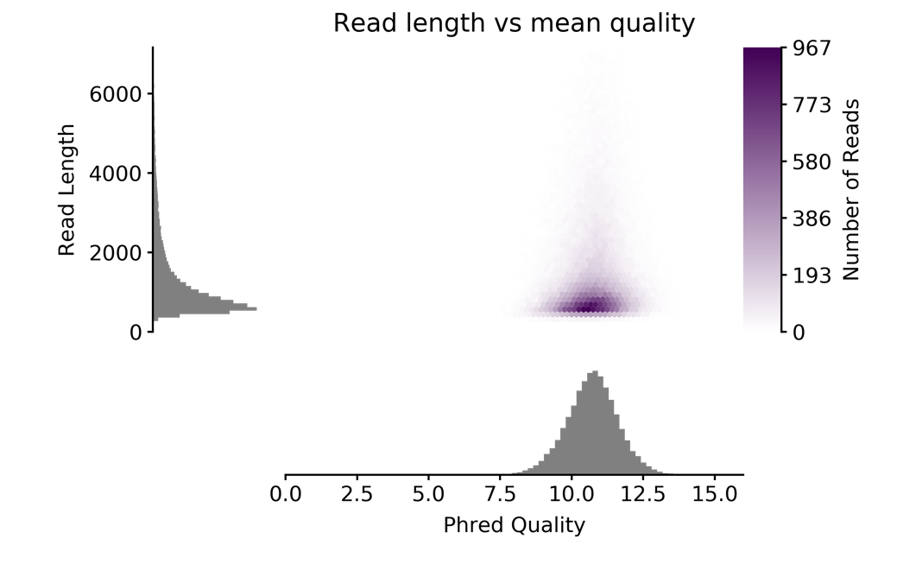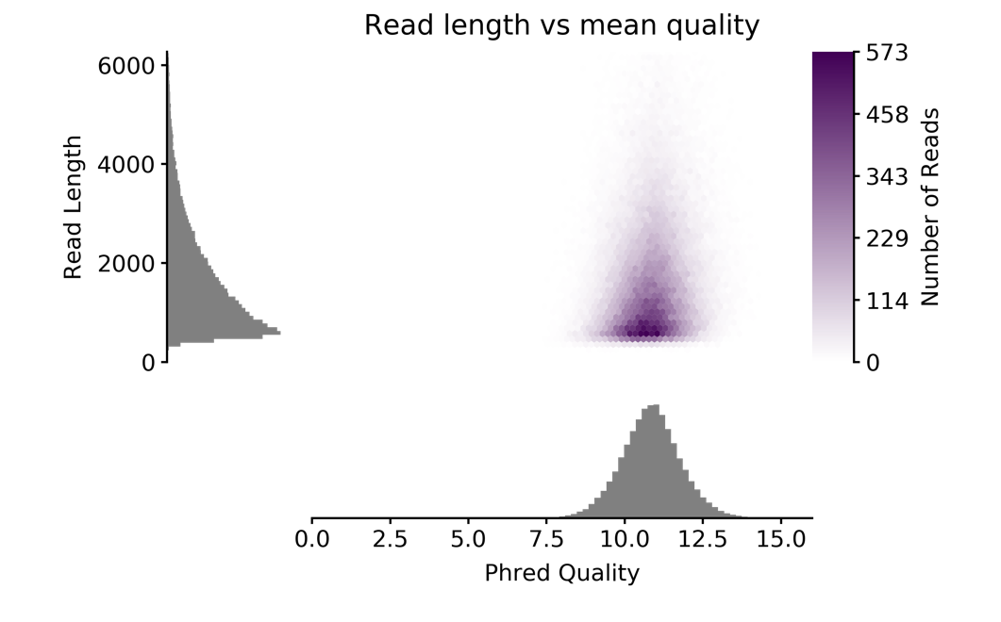

Figure S1. Top: Mayagüez Sample, Bottom: Rincón Sample. ONT MinION sequencing results with read length and Phred quality scores graphed via python PAUVRE program.

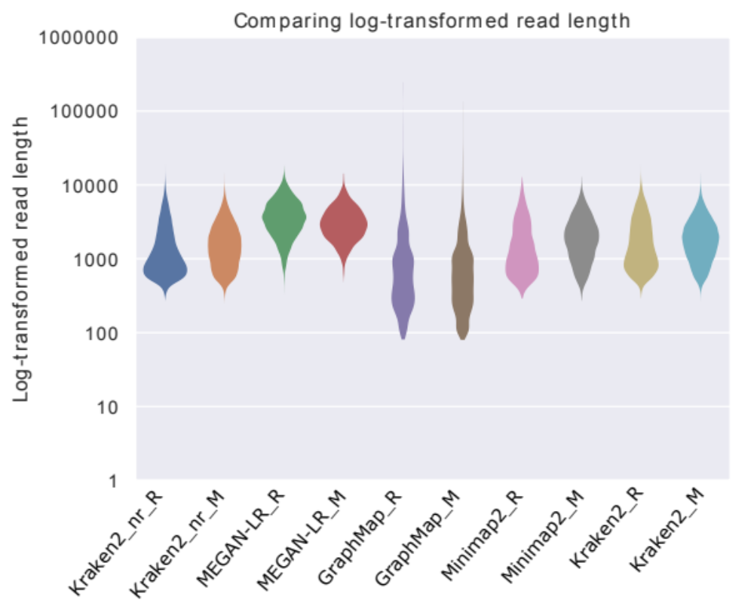
Figure S2. Nanoplot hourglass plots of log-transformed classified read lengths. Kraken2_nr = Kraken2 run in protein mode against the NCBI nr database, MEGAN-LR was also run against the NCBI nr database. _R = Rincón sample, _M = Mayagüez sample.

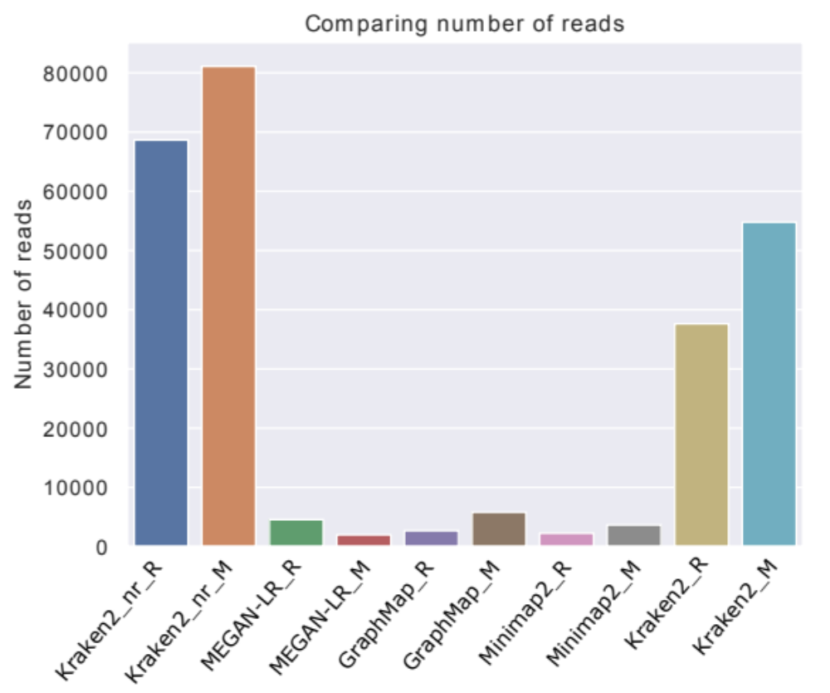
Figure S3. Nanoplot absolute read counts between different methods of annotated reads to kingdom or better taxonomy classification. Kraken2_nr = Kraken2 run in protein mode against the NCBI nr database, MEGAN-LR was also run against the NCBI nr database. _R = Rincón sample, _M = Mayagüez sample.

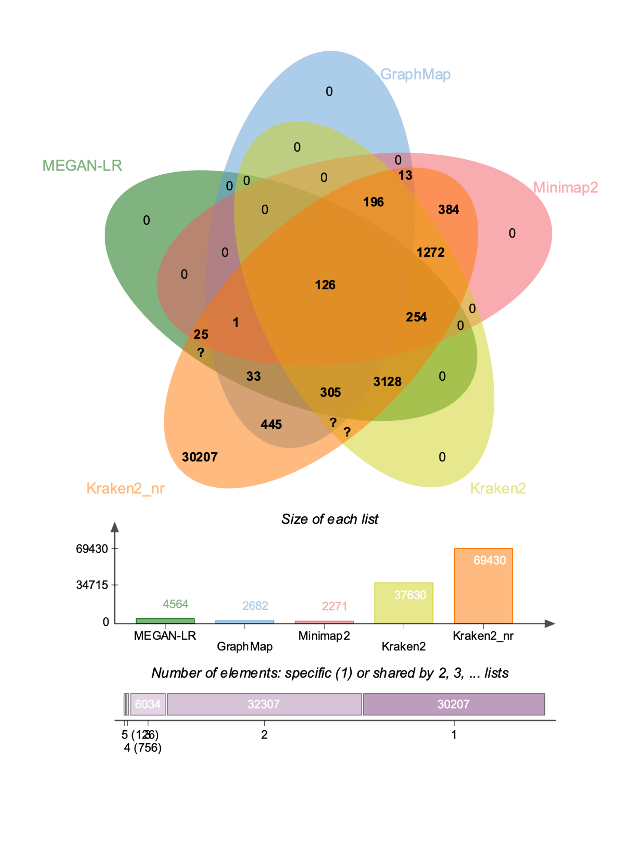
Figure S4. Venn diagram of annotated reads by different methods for the Rincón sample.

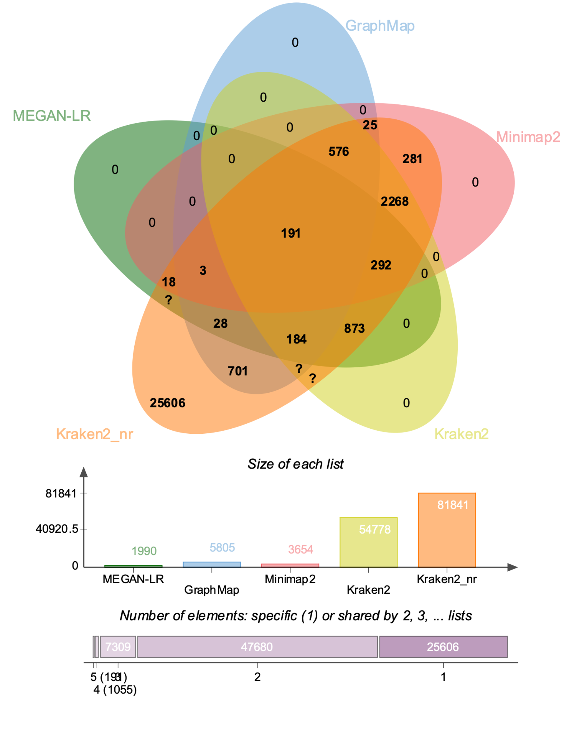
Figure S5. Venn diagram of annotated reads by different methods for the Mayagüez sample.
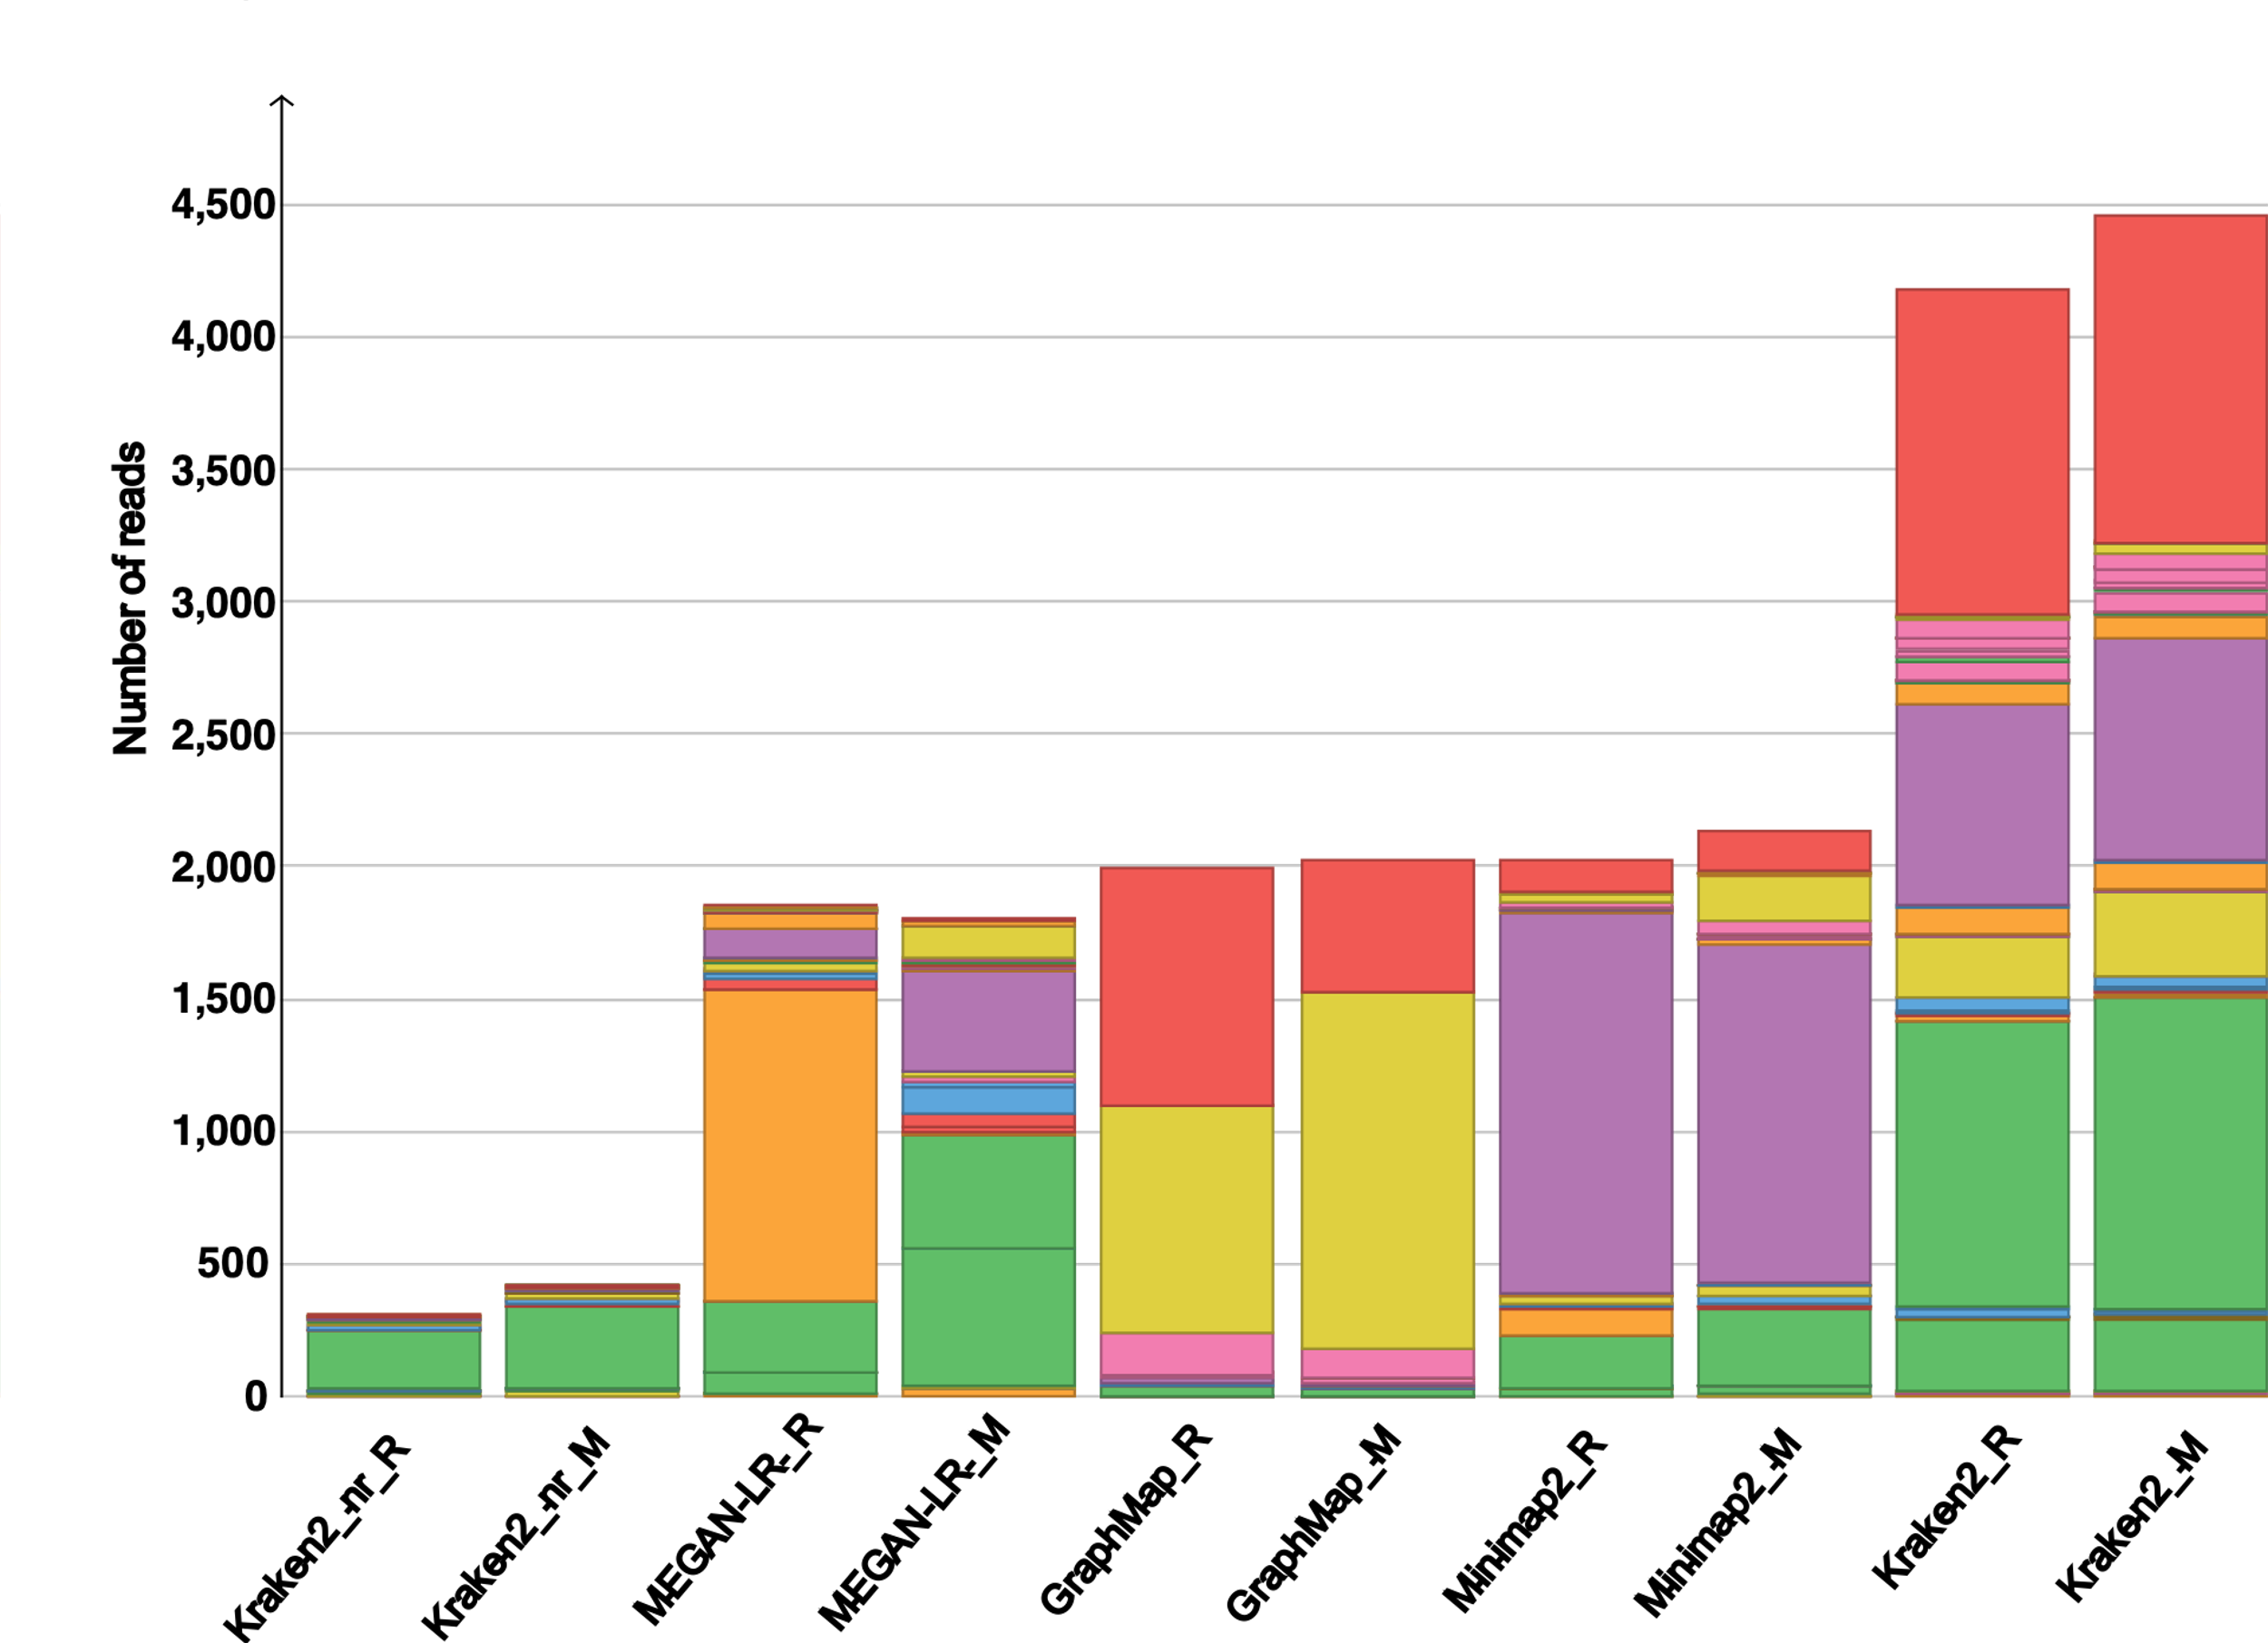
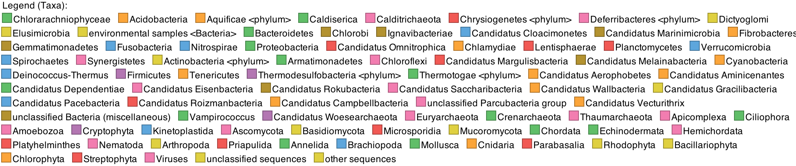

Figure S6. Phylum taxonomy classification stacked bar chart of normalized read counts via MEGAN6: Normalization is achieved as follows: for each sample S, and each class C, report |C|/|S| *m, where |C| is the count for the class in S, |S| is the total count assigned for sample |S| and m is the minimum size of any of the samples. Kraken2_nr = Kraken2 run in protein mode against the NCBI nr database, MEGAN-LR = MEGAN-LR run against the NCBI nr database. _R = Rincón sample, _M = Mayagüez sample.

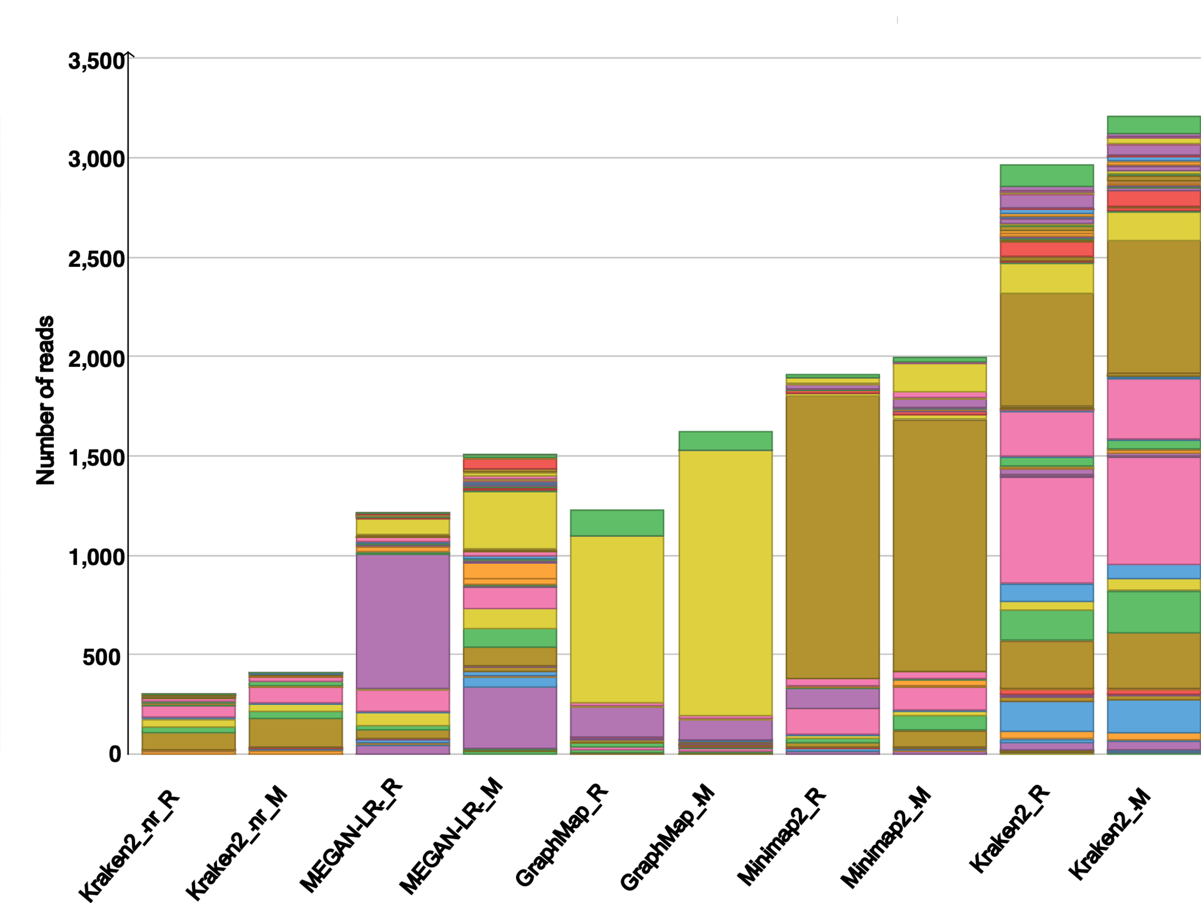
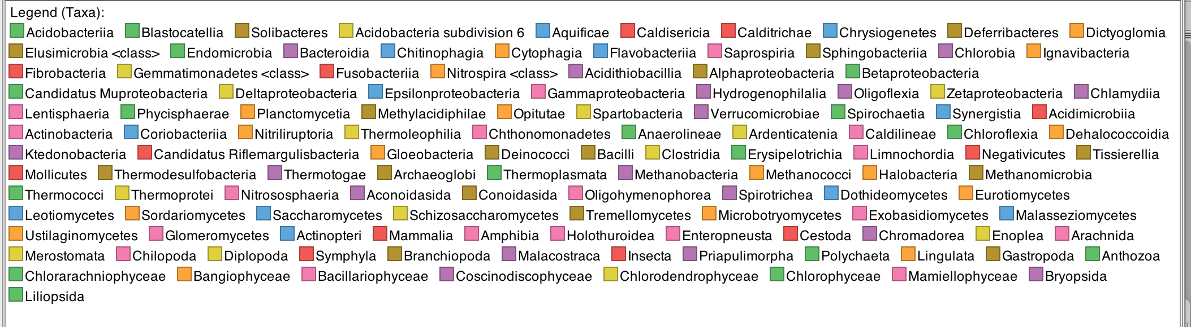
Figure S7. Class taxonomy classification stacked bar chart of normalized read counts via MEGAN6: Normalization is achieved as follows: for each sample S, and each class C, report |C|/|S| *m, where |C| is the count for the class in S, |S| is the total count assigned for sample |S| and m is the minimum size of any of the samples. Kraken2_nr = Kraken2 run in protein mode against the NCBI nr database, MEGAN-LR = MEGAN-LR run against the NCBI nr database. _R = Rincón sample, _M = Mayagüez sample.

